**ARE US GUN LAWS RELATED TO GUN VIOLENCE?**

A Data Analysis Report

by Leanne Kendall

2. Summary

Gun control has been a long-debated topic in the US. Some people believe having stricter guns laws will improve the overall safety in society and others disagree. This article argues that gun control laws “do not work”. In saying this, they propose that gun laws have no affect on the amount of gun violence incidents that occur under the area in which the laws are in place. In this analysis, I challenge this view by creating a model that predicts whether the gun violence incidents in a respective area are ‘high’ or ‘not high’ based on the laws in this area.

Data in this analysis consists of gun violence incidents from 2013-2017 in each of the 50 US states, and each state’s corresponding gun laws for the year being observed.The research finds that whether an area has a high or not high count of gun violence incidents can be predicted with around 80% accuracy, signifying that gun control laws so, in fact, impact the gun violence in that area.

It is through this analysis that I found there was a clear a relationship between gun laws and the amount of gun violence. Additionally, I recommend certain laws such as the alcohol treatment law, the immunity law, and the nosyg law be either investigated and/or implemented by governments, as they were significant predictors that were negatively associated with crime.

4. Introduction

To enact gun control laws or to not? This has been a long-standing question in US politics, as gun violence continues to be prevalent in the country. There are studies that show gun control laws have no effect – or even a negative effect on the amount of gun violence in that area of jurisdiction. One article in particular, “Why Gun Control Doesn’t Work” written by the NRA-ILA asserts that stricter gun laws have led to more crime. The author sites the examples of New York and Chicago—“cities with some of the most stringent gun laws”— as having extremely high gun violence rates. The author uses the following data to support this claim: “Shooting and murder rates in Chicago surged 50% in 2020, and that city recorded the highest number of gun-related homicides on record.” Additionally, they site “New York City saw similarly alarming statistics. In 2020, homicides increased 41%, and shootings increased an astounding 95%”. Although these assertations may be true, picking out two locations in the United States and using them to draw conclusions about the nation as a whole is rather ignorant. In this study, I use gun violence and gun law data from all 50 states, from 2013-2017 to draw conclusions about the effect that gun control laws have on the amount of gun violence that occurs.

In opposition to this article, I can confidently say that gun control laws do have an effect on the crime in their respective areas. The purpose of this report is not to say that every gun control law is good, nor is the purpose to say that the more gun control laws the better. However, through this analysis I am proving that there is, in fact, a relationship between gun control laws and violence – and I will be exploring how different laws effect this level of crime, both positively and negatively.

In this report I will explain the modeling process, analyze its results, and draw conclusions that will help direct governments in their gun control law-making. The report will briefly cover the methods used to model the data, cover the model evaluations, and finally give recommendations based on the results. I will also recognize the shortcomings of this analysis and the ways in which I believe it could be improved.

5. Methods and Findings

**Data Exploration**

In the first step of modelling the data, I began with data exploration. This entails creating graphs and visuals that depict the data being used in this analysis. I started with two different data sources: Gun violence data between 2013-2017 originating from the EDA, or the US Economic Development Association, and the federal regulations of firearms from 1991 to 2017 (although only 2013 through 2017 were used for modeling) for all 50 U.S. states.

Below I have outlined some initial insights from the data sources:

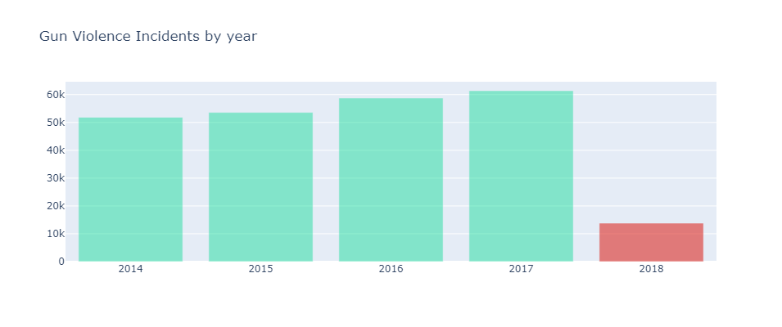Figure 1: Gun Violence Incidents by Year

Figure 1 shows a steady increase in gun violence incidents from 2013-2017 in the US. 2018’s low number is a result of only about a quarter of 2018 being included in the dataset. 2018 was removed for modeling purposes.

Figure 2: Average Gun Violence Incidents by Month

Figure 2 shows July and August having the most gun violence incidents on average from 2014-2017.

Figure 3: Gun Violence Incidents per State

Figure 3 shows California, Texas, Florida, and Illinois as having the most amount of gun violence incidents, however, this visual is not adjusted for population. Therefore, it makes sense that some of the most populated states have the most gun violence incidents.

Figure 4: Gun Violence Per State – Population Adjustment

When adjusted for population, Alaska, Delaware, and Louisiana lead the nation in gun violence.

**Data Preparation**

I cleaned and prepared the data through the following steps:

* Sliced the date column in order to create separate columns by year and month. This way trends between years and months can be seen.
* Inserted a missing row that the author of the dataset on kaggle had said was missing.
* Added in population data from the US census and added it to the dataframe in order to be able to view each state’s stats relative to its population.
* Grouped the gun violence dataset by state and year and added an ‘incident_count’ column that contained the count of gun violence incidents for each respective state and year.
* Merged this data frame with the laws data frame on the state and year columns in order to have each state’s laws for the year the gun violence incident was committed be associated with each incident count.
* Chart, histogram

  Description automatically generatedI plotted the incident count variable below then created an incident_high column that is set equal to 1 when the incident_count is greater than or equal to 600. This set up the target variable for the logistic regression that was performed.

**Data Modelling**

I performed both linear regressions, with the incident count as my target variable, and logistic regressions, with whether the incident count was high as my target variable. The independent variables in both models were the various gun laws either in place or not in place in the state and at the time of the gun violence incidents.

The best version of the linear regression had an R^2 of 0.81, meaning that 81% of the variability in the data could be said to be explained based on the gun laws. The test data showed that the mean squared error, or the average squared difference between the predicted values and the actual values was 400 incidents. For context, if we used a model that predicted the mean of incidents every time, we would get a mean squared error of 737 – meaning that by using the linear regression, we improve our prediction or have a ‘lift’ of about 84%.

The best version of the logistic regression, which was used to predict whether the incident count was ‘high’ (equal to or over 600) had an accuracy 0f 83%. It’s prediction results are depicted in the confusion matrix below:

The logistic regression had a very high sensitivity, or true positive rate – being able to identify 86% of all high gun violence incidents correctly.

**Model Evaluation**

Based off my model results, I decided to use the logistic regression because of its explainability factor. The independent variables are easier to plot against the binary dependent variable and clearly explain.

**Model Variable Analysis**

Finally, I created visualizations to assess and better understand the effects they were having on the model.

Certain laws show lower proportions of high incidents:

* Alcohol treatment (Law that prohibits firearm possession by people who have received treatment for alcohol-related problems that exceeds a state-defined threshold).

* Violentpartial (This law prohibits firearm possession by people who have committed violent misdemeanors punishable by more than one year of imprisonment)

* Nosyg (A Law that states the use of deadly force is not allowed to be a first resort in public. This is sometimes referred to as a "stand your ground" law. There is a duty to retreat).

* Immunity (When the state does not have a law that provides immunity to gun manufacturers for damages caused by their products or which prohibits the state or local government from filing lawsuits against gun manufacturer. Protections for gun dealers do not count).

I would also like to recognize that not every law in the model was associated with lower rates of high crime:

* Chart, bar chart

  Description automatically generatedUniversalpermith (Law that requires individuals to undergo a background check to purchase handguns, either at the point of purchase or through a license/permit application. This may or may not include exemptions for buyers who have already undergone a background check for a concealed carry permit or other licensing requirements).

6. Conclusions and Recommendations

To conclude, the accuracy of both the linear and logistic model signifies there is a relationship that exists between gun laws and the amount of gun violence. In this analysis, and detailed in findings, certain laws such as the alcohol treatment law, the immunity law, and the nosyg law stuck out to be negatively associated with high crime. These are the laws I recommend governments investigate and, if they deem appropriate, implement in their respective states.

However, oversimplifying this very complex issue by saying all gun laws reduce crime would be negligent. There are other factors that were not considered in this study, such as population density, that greatly factor into these numbers. Additionally, the results show certain laws, such as the universal permit law, that are positively correlated with high crime.

That being said, I do believe this study proves one thing to be very true: There is a clear effect of gun laws on gun crime. An accuracy score of over 80% in both the linear and logistic regressions show that there is an undeniable relationship that exists between the two. With more time, I would’ve liked to refine my models more, adjust gun violence crimes based on population, and consider grouping some of the law variables together to get a more solid understanding of how the laws were affecting the outcome of crime.

7. References

Nra-Ila, and National Rifle Association. “Ila: Why Gun Control Doesn't Work.” NRA, https://www.nraila.org/why-gun-control-doesn-t-work/.